Press Pack
Event – Walk of Truth
Place – Central London. Police Headquarters, Parliament and 10 Downing Street,
Purpose - Family members who have lost loved ones due to ending of life known to be attributes to the Child Maintenance Service will be joined by existing paying parents and stakeholder organisations to complete a London walk where they will hand deliver a request for a public enquiry into documented fraud by the CMS, accountability for the deaths and that the CMS is decommissioning immediately.
The document will include data from our consultation, evidence of the illegal practices situated within the CMS and case studies.
Route of Walk of Truth – Leaving from 10 Downing Street to Police Headquarters then on the Parliament where individuals will hand deliver a copy of the letter to each of their MP’s. From here we will walk back to 10 Downing Street where the document will be delivered to the Prime Minister.
When – 5th July 2023
Additional information
Split the Difference is a human rights organisation that raises awareness on the inequality in services for boys and men. In autumn of 2021 we received a request from a father who lost his only child, to support him in raising awareness on the mismanagement of the CMS.
Over a period of approximately 6 weeks Split the Difference evaluated evidence present to us and through connecting with a pool of 75000 affected paying parents have conducted research and analytical work that show gross, illegal activities being purposefully engaged by the CMS a profit making government department operating within the DWP.
In this role to raise awareness we were invited after being recognised as an advocating agency
Split the Difference and collaborating agencies urgently calls for public inquiry into the Child Maintenance Service and it fraudulent management practices. We ask that the government seeks accountability and that the CMS is decommissioned due to the startling evidence from hundreds of cases of fraudulent calculations, resulting in paying parents taking their own lives.
As a government recognised advocating organisation for paying parents and second families we have interrupted a vital research project to urgently respond to the application for a new child support enforcement bill which is being forced with excess speed through the House of Lords.
Split and its volunteers have grave concerns that this Bill will grossly increase the deaths of parents who are already having up to 85% of their monthly income stolen because of inaccurate calculations, false debts and false secondary incomes.
An ongoing 18 month research project conducted by Split the Difference has identified alarming findings regarding the Child Maintenance Service (CMS) that shows three decades of statutory abuse against paying parents and their families.
Split the Difference has identifed that the Department of Work and Pensions, the Child Maintenance Service (a profit making agency run by private businesses) and parliamentary leads have consistently broken numerous laws pushing thousands of parents to take their own lives.
Sally-Anne Burris, one of Split the Differences company directors says: “I have designed and delivered government procured services for over 20 years, the research completed so far on the impact on paying parent and their families can only be described as criminal.
“In every single case and there are thousands of them, this agency has shown itself to be nothing more than a rogue, illegally operating department that is brutally ripping the soul out of children and their families, leaving a path of death and destruction that we have mapped back 30 years.”
“Every single case we hold has been verified, every single action, report, review of the CMS and governing stakeholders is cross referenced and recorded. “Every parliamentary oral hearing, and report submitted to central government by the DWP, CMS, ICE, the National Audit Office, private business and third sector contractors, evidences what can only be determined as purposeful coercive manipulation of facts which strips central governments ability to audit and monitor the CMS.”
In collaboration with a dedicated group of professional volunteers, Split the Difference has uncovered tens of thousands of irrefutably evidenced fraudulent calculations, resulting in unwarranted demands for false arrears and false secondary incomes from parents. The organisation is now demanding a public inquiry to shed light on the illegal and damaging activities perpetrated by this government agency which equates in excess of 4 billion pound.
During the extensive 18-month research project, Split the Difference and its committed volunteers delved deep into the accuracy and transparency of financial calculations pertaining to child support and related obligations. The meticulous analysis of financial records, documentation through cases and FOI’S, and THE extensive data evaluation PROCESS has unearthed a distressing pattern of fraudulent practices within the CMS.
These deceitful calculations artificially inflate the amounts owed by parents, which results in a brutal psychological and emotional, tactical assault on paying parents, crossing the boundaries of bullying and harassment legislation, human rights, corporate manslaughter, fraud, modern-day slavery, and more. This alarming alignment with organized crime exposes a deeply concerning collusion between the CMS and illicit activities, causing immeasurable harm to vulnerable parents who find themselves entangled in a web of manipulation and exploitation.
The systemic nature of these fraudulent practices reveals a shocking disregard for basic human rights and a flagrant violation of the very principles that should protect and support families in need.
Split the Difference and its volunteers have contributed to the Department of Work and Pension Select Committees consultation, has worked tirelessly in an attempt to raise awareness, writing and sharing evidence with every key department and leadership within governance including MP’s, The Prime Minister and more.
Work carried of within the 18 months;
- Connecting with ready formed community groups holding a calculated membership of 75000 paying parents and the families of those who have lost their lives due to the CMS/CSA
- Built a portfolio of hundreds of cases which include ‘paying parents’ who have experienced forced sales of homes due to false debts, homeless, loss of employment, loss of businesses, loss of life, parental alienation and more. This has included the analysis of the corporate behaviours and management systems within each case.
- Mapped the contracts of private businesses involved in the management of this service, i.e. SERCO, G4S and more
- Mapped leadership over three decades, individuals, governmental leaders and their relationships with private contractors
- Mapped the governments stakeholder reporting, i.e. DWP, ICE (independent case examiner for the CMS) the DWP select committee, the national audit office, the treasury, oral hearings and additional reporting mechanisms within governance. This also includes private business practices and reports released from contractors.
In addition to the research, Split the Difference conducted a comprehensive questionnaire and consultation with parents directly affected by the CMS. The foundation of the consultation was formulated using legislation, guidance and policy as a reference to best practice enabling Split the Difference to map the gross neglect of the CMS’s its failings and illegal activities.
The results of this consultation are both shocking and deeply concerning, revealing the dire financial and emotional situations experienced by paying parents. In completing a comprehensive questionnaire parents, were asked to only answer questions they could provide evidence for.
The latest statistics from the CMS say that 910,000 children are currently being supported by the CMS, we know globally that the average family unit consists of Two parents, and two children (2.2). For your information when the CMS calculate how much a paying parent is required to pay, they do so from their gross income, before tax, N.I. etc.
Consultation statistics
Below is some of the key revelations taken from the survey which shows legislation and guidance being broken of reflects impact on paying parents which includes that:
- 72% of paying parents said they have arrears placed on their account they can prove they do not owe.
- 22% of paying parents are paying 40% of their gross income to the CMS each month
- 17% of paying parents are paying 50% of their gross income to the CMS each month
- 10% of paying parents are paying 60% of their gross income to the CMS each month
- 5% of paying parents are paying 75% of their gross income to the CMS each month
- 4% of paying parents are paying 85% of their gross income to the CMS each month
- 46% of paying parents said that when their income has changed by 25% yet the CMS refuse to do a mandatory re-calculation.
- 36% of paying parents say the CMS have refused to calculate child support from the current tax year instead choosing to calculate a different year, some dating back to 2016.
- 45% said the CMS have interfered with a private arrangement agreed between each partner.
- 51% of paying parents have been forced onto collect and pay for no justifiable reason, which forces them to pay a percent of their income to the CMS as profit.
- 11% of paying parents have lost their homes and become homeless because of debt they can prove they do not owe the CMS.
- 19% of paying parents are being forced to pay child maintenance when they have 50/50 share parenting.
- 37% of paying parents are being forced to not accept employment because of a false debt CMS has placed on their account.
- 34% of paying parents had been forced to give up employment because of a false debt placed on their account.
- 41% of paying parents have become alienated from their children due to the CMS
- 39% of paying parents have had their contact with their children decrease due to the CMS
- 4% of paying parents have been imprisoned for false arrears
- 55% of paying parents have complained to multiple agencies due to false arrears
- 96% of paying parents said they are experiencing fear/anxiety/panic/depression because of the CMS
- 90.8% said they are experiencing intimidation, threats, verbal and mental abuse, bullying and harassment from the CMS
- 97.2% of paying parents said they are being made to feel scared, distressed, threatened and victimised by the CMS.
- 4.5% of paying parents have been forced to sell assets by the CMS, i.e. their homes to pay off false arrears.
- 61.9% of paying parents said they have been forced to seek medical assistance because of the CMS
- 68.6% of paying parents said they have considered taking their own life because of the CMS
- 25.1% of paying parents said they had been refused to be taken off collect and pay when they have proven there is no justification for them to be on there.
- 86.2% of paying parents said that they believe the CMS is committing fraud.
- 7.5% of paying parents said they are still being forced to pay CMS even though the children live with them 100% of the time.
- 79.6% of paying parents said the way in which the CMS dealt with their case was incompetent.
- 86.6% of paying parents said that the way the CMS dealt with their enforcement management is incompetent
- 87.3% of paying parents said the CMS’s customers services department are incompetent
- 71.1% of paying parents said they were forced to use the CMS
- 82.5 of paying parents said the CMS payments were not affordable
- 49.4% of paying parents said they were paying a debt they were told was from the time CMS was CSA.
- 96.7% of paying parents said they believe the CMS discriminate against paying parents
- 95.7% of paying parents said they believe the CMS and other services are used to abuse parents through false allegations, refusing to accept documented evidence
- 65.3% of paying parents had said they have reported to the CMS mental health issues because of their services.
- 99.8% of paying parents said they want a public enquiry into the CMS, that they want accountability and that the CMS is decommissioned.
The above stats can only be published if referenced to Split the Difference CIC
(© Split the Difference CIC July 2023 )Company No: 12020100)

The Child Support Enforcement Bill will put enforcement measures into the hands of administrators. This will mean, the removal of passports, driving licences and potentially, more severe penal measure like tagging will be forced on paying parents already being forced to take their own lives.

Financial facts in the calculation of CMS.

- A recipient parent of child maintenance does not have to declare the payment, where a resident parent is the recipient of universal credits, regardless of the value of payment which can be between 40 and 85% of the paying parents monthly income, this is never used in a benefit calculation.
- Commonly resident parents are left in a marital home where the paying parent is left paying the total mortgage, in all cases we hold, the CMS refuses to acknowledge this as part of the child support payment

The gravity of these findings compels Split the Difference to urgently call for a public inquiry into the CMS. The organisation will present an overview of research data, along with a petition of the voices and testimonies of affected parents, demonstrating the severe damage and illegal fraudulent activities perpetrated by this government agency. Split the Difference is committed to ensuring justice, accountability, and the dismantling of the CMS, which has inflicted immeasurable harm on countless families across the nation.
Phot of Split the Difference Director Sally-Anne Burris
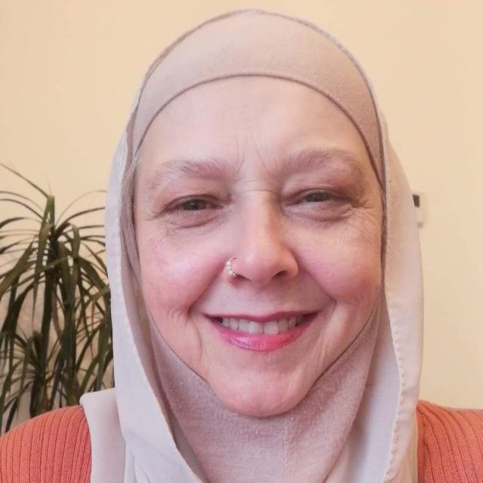
For media inquiries, interviews, or further information, please contact:
Sally-Anne Burris
Split the Difference CIC
07724587078
About Split the Difference role in the CMS campaign to raise awareness
Split the Difference is a leading human rights advocacy organisation dedicated to promoting fairness and equality within services for men, boys and their families. The organisation tirelessly works to expose and rectify discriminatory and fraudulent practices.
We are a recognised advocating agency for paying parents, ensuring parents are not burdened by false arrears or fraudulent secondary incomes. Through research, advocacy, and collaboration, Split the Difference strives to bring about meaningful change, protect the rights of families, and hold government agencies accountable.
Supporting Links
Written evidence from Split the Difference (CMS0029) entered into the DWP Select Committees consultation in spring 2023 – The full report is attached https://committees.parliament.uk/writtenevidence/115622/html/
Split the Difference website - https://www.split-the-difference.com/child-maintenance-services-cms
Youtube - https://www.youtube.com/channel/UC3cMfF7f_juVIxn7cEoGazQ

Families who have lost loved ones;
From Joanna, sister to Jonathan Oneill – Son, father and brother who took his own life due to the CMS.
In November 2021, Jonathan O’Neill took his own life as a direct result of the CMS, naming them in his final note
Jonathan battled with the CMS for years, informing them of his financial hardship and regularly telling them 'I can't afford to live'.
Several errors have been made in his dealing with the Child Maintenance Service which include
- Over £4000 in false arrears added to his account - These were later removed but an inflated payment had been made for months as a result of this. No monies were ever repaid back to Jonathan
- The CMS admitted to illegally taking over 40% of Jonathan's wage, this is factually evidenced.
- A telephone recording was lost when the CSA transferred to the CMS. This call was critical as it was the RP, stating he had paid cash via a family based arrangement previously. This was later denied and further arrears were added onto the account.
- Jonathan’s mother, 4 weeks before he took his own life wrote to the CMS to tell them she had grave concerns about Jonathan’s mental health, begging for help, they did nothing. We are approaching the second anniversary in that he took his own life and his mum still hasn’t had a reply.
Jonathan was instructed to pay £689 per month for one child in October 2021. Joanna his sister supported him in writing to the CMS, explaining that the calculations were wrong and that Jonathan would have to leave his employment of 14 years (working with the disabled) and that he would lose his home, but they upheld the decision. (Please see the statistics included in this press pack that shows the loss of employment, homelessness etc)
Following Jonathan's death, they continued to pursue him for money up until the February, 4 months later. They even thanked him for uploading his own death certificate. The barbaric management of this agency, the complete systemic dismissal inhuman, systems, the lack of respect and human values mean nothing, Jonathan was simply a number to them, not a father, son, brother.
Joanna, Jonathan’s sister says:”We were incredibly close and our family has been left shattered by this. He leaves behind a daughter (whom he was alienated from) a loving mother and two nephews who he was also godfather to.
“The whole system is broken and unwilling to listen to those who are struggling. The countless errors left him feeling like he just simply couldn't carry on. As a family, we hold the CMS to account for his death. If they had listened to him, to our mother and not shown him such negligence, he would still be here today.”
Jonathan has an incredible work history, he was part of a construction team that took part in renovating homes for disabled people. His employer, the people worked with were devasted by his loss, telling Split the Difference, “Anything we can do to highlight the devastation this agency has left for all who knew Jonathan we will do.”
No one should loose their lives, their children, their brother, their father because of the brutal actions of a government agency and its contractors. Jonathan’s case is black and white, air tight and in no way can anyone deny who caused his life to end.
Photos
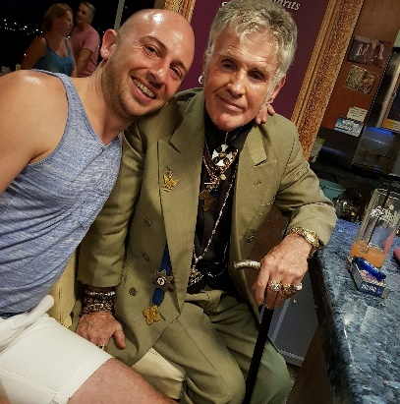

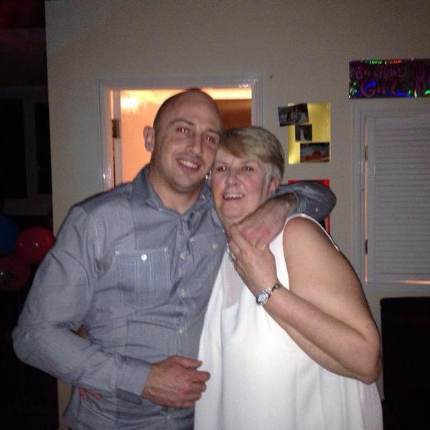
Link to facebook page - https://www.facebook.com/jonny.oneill.5494
You can contact Joanna Smith - Jonathan's sister through Split the Difference
Email - sally.burris@split-the-difference.com
Mob – 07724587078
Gavin Briggs
Son, father, nephew fiancé, who sadly took his own life
- From Ian Briggs, father of Gavin, Key details in Gavin’s case
CMS added £26,000.00 additional income to his case at this time this figure was known to be fictitious proven by factual evidence
- The CMS added £16,000.00 arrears to Gavin’s account, this is also a fictitious figure.
- The CMS where trying to take child maintenance payments for two children he was already paying for by private arrangement under an appointed court order, this goes against CMS guidelines.
- Gavin appealed these figures on two occasions but the CMS ignored him.
- With CMS payments and court order payments Gavin was left with £154.00 a month to live on. By their own regulations CMS can take no more than 40% of some ones income. Gavin’s income was £52000 per year.
- At Gavin’s inquest the coroner would not accept any evidence presented to him and failed to advise the family that we could have requested an article 2 inquest. The CMS would have had to attend to answer questions. Now under legal consultation this is a failing of due consideration and through research is evidently common practice where court refuse to follow due process.
- There have been other suicides related to the CMS but coroner’s seem to refuse to acknowledge this fact.
Gavin was the only child of Ian Briggs, both were ex-service men, both sharing a full close family relationship. Ian says: “I have been campaigning for 3 years and no one will listen or do anything about the fact that the CMS is breaking the law time and time again driving parents to suicide.
“The effect of Gavin’s suicide and the subsequent stone walling that have been put up to prevent me finding out how the CMS got Gavin’s case so catastrophically wrong has been devastating and frustrating, especially knowing that more parents are committing suicide due to the CMS and no one seems to care.”
Ian Briggs is why Split the Difference started its research, after bringing his story to us, in just a few weeks of reseearch, reading Gavins case and the supporting, factual evidence that was found that makes it clear that the CMS is fraudulently loading parents with false debt, we couldn’t step away. In fact there are clear patterns of behaviours that are on view in the governments own reporting processes and that of ITS subcontractors.
Ian says: “When one suicide is attributed to a television program there has proven to be public outrage and an independent inquiry is pushed forward. “How many more suicides caused by CMS wrong doings need to happen before these fathers, their children and families get the same priority.”
Links
Website - http://www.justice4gavinbriggs.com/
Photos
You can contact Ian Briggs please contact
Email - sally.burris@split-the-difference.com
Mob – 07724587078
Collaborating Agencies
Equal Start
Founder – Shaun Buchanan
Situated within London, Equal Start for Parents Aims to Achieve Equal Rights for Non-Resident Parents and Ensure Child Well-being
Equal Start is an organisation founded considering the needs within social justice and human rights. Shaun Buchanan, is committed to promoting equal rights for non-resident parents and prioritising the well-being of children. The mission of Equal Start for Parents is to ensure that children have the stabilising influence of relationships with both parents, particularly during relationship breakdowns. The organisation seeks to address the existing biases and transform cultural attitudes in the United Kingdom surrounding public bodies and Family Courts to prevent non-resident parent bias and uphold the rights of all parents in contested residencies.
Equal Start for Parents focuses dominantly on the following key initiatives:
- Presumption of Shared Care: The organisation will advocate for a presumption of shared care in the first instance during relationship breakdowns. This presumption aims to provide the children and non-resident parents with equality and ensure their meaningful involvement in the lives of their children.
- Transparency in Family Courts: Equal Start for Parents will campaign for greater transparency within the Family Courts. The organisation aims to reduce discretionary powers of judiciary officials and conduct a comprehensive review of cases resulting in complaints and contentious decisions. By making the process more accessible and reducing costs, the organisation seeks to enhance transparency and fairness within the Family Court process, including involvement of stakeholders.
- Reform of Complaints Procedure: Equal Start for Parents will work to reform the complaints procedure surrounding local authority child services, particularly when there is is evidence of false allegations and the purposeful perversion of justice and/or parental alienation. The organisation also advocates for consistent sanctions, equivalent to those in criminal cases, for public office holders found guilty of such misconduct. This reform aims to ensure impartiality within organisations such as Cafcass and Childrens Services, preventing biased influence on judiciary decisions regarding residency and contact arrangements.
- Independent Regulator: The organisation strives to raise awareness on the need for a new independent regulator dedicated to vigorously upholding the rights of non-resident parents. This regulator will work to monitor and enforce compliance within fair equitable rights, ensuring fair treatment for children parents and close family members involved in contested residencies.
- Data Transparency: Equal Start for Parents aims to conduct research, collecting and providing statistical evidence on failings within the family court and stakeholders where contested residencies exist, contributing to the formulation of better, more effective performance reviews and preventing cronyism among staff. By making this data available, the organisation seeks to ensure accountability and transparency in decision-making processes.
In addition to its advocacy efforts, Equal Start aims to engage in outreach work to support parents and families:
- Providing free independent advice on access and rights to children.
- Conducting workshops to educate parents on their rights concerning residency, contact, and the Child Maintenance Service.
- Offering counselling services to help individuals cope with the trauma of parental alienation.
- Sharing information on the legal processes for unmarried fathers to obtain full custody of their children where the need is evidenced outside a shared care arrangement i.e. risk management.

Shaun Buchanan
A passionate founder of Equal Start for Parents, emphasising the urgent need for major reform within public bodies, including Family Courts, Local Authority Child Services, Social Work England, Child Maintenance Service, Crown Prosecution Service, and Cafcass. Shaun proposes improving outcomes by incorporating citizen governance roles within Ombudsman's offices and granting them golden veto powers in high-conflict cases with evidence of public malfeasance.
Shaun says: “The false arrears scandle from the CSA/CMS has led to untenable levels of male suicides, as a father who has witnessed the effects of this tragedy, I feel it the responsibility of agencies and professionals to ensure this doesn’t continue.
“Supporting children, their fathers and extended families, I feel the responsibility of speaking out, all of the volunteer agencies and individual professionals working with Split the Difference feels there is no choice but to step up and ensure these illegal practices cease.”
Shaun Buchanan (photo)
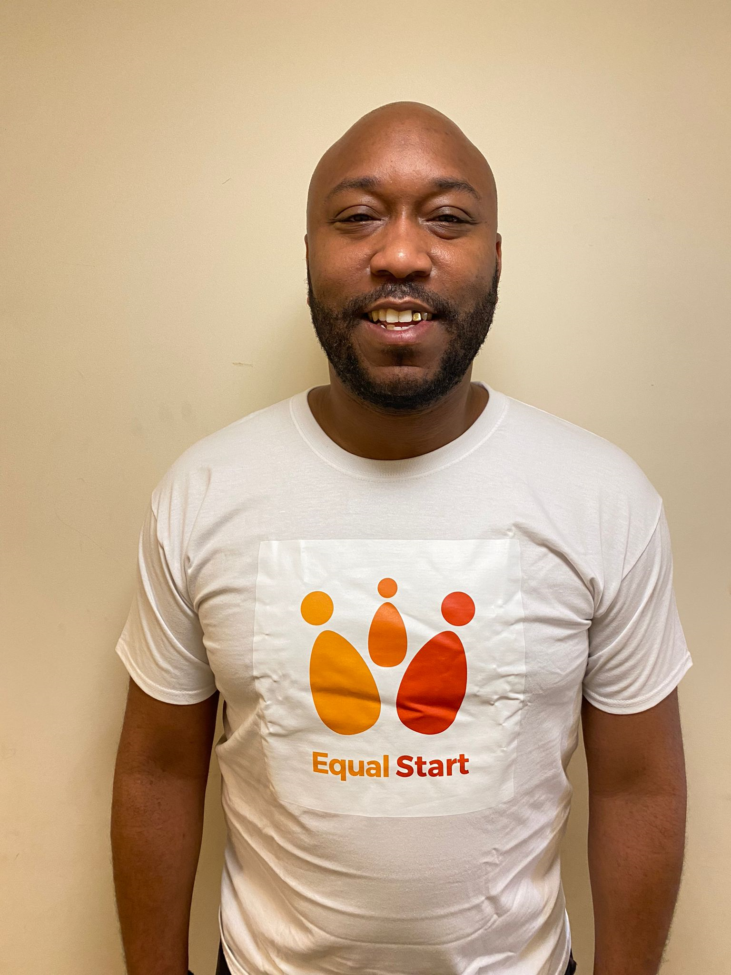
Personal and professional information about Shaun Buchanan
Shaun is a passionate social justice and human rights campaigner. The founder of Equal Start in 2018 recognising that the bias and trauma and abuse of families going through the family court process had become too flagrant. Through research and the personal experiences of parents he was supporting Shaun believes major reform is needed of the following public bodies; Family Courts, Local Authority Child Services, Social Work England, Child Maintenance Service Crown Prosecution Service and CAFCASS.
Shaun has explored solutions to improve the outcomes for children, their parents and extended families and believes if citizens were given governance roles within an ombudsman service and were awarded veto powers, in high conflict cases when there is proof of public malfeasance, that the system would be far more centred around the children and families needs enabling a balanced non bias perspective.

Mr Buchanan’s hobbies include, reading world history and current affairs, boxing, chess, cricket and football. He has written two publications
‘Road of Life - https://amzn.eu/d/8AVpJOT
and
‘Will the Black Press survive the financial crisis.’ - https://www.lap-publishing.com/catalog/details/store/gb/book/978-3-659-34999-7/will-the-british-black-press-survive-the-financial-crisis

Muslim Fathers Support Forum (MFSF)
The Muslim Fathers Support Forum (MFSF) was founded by Ahmed Raidhan. With the rise of divorce rates also affecting the Muslim community, and an ever increasing rise in the number of cases where fathers are loosing access to their children, Ahmed and a growing group of volunteers offer support in the community centred around a child’s rights to both parents.
Geographically based in Birmingham, MFSF is a dedicated peer support group assisting fathers in navigating the practical, emotional, and mental aspects of divorce and separation and sees an urgent need within their own stakeholders to join and support the child maintenance service campaign led by Split the Difference.
Ahmed says: “The CMS is an oppressive, exploitative system that promotes acrimony. “At MFSF we have seen the unequitable, emotional and financial ruin of hundreds of fathers struggling to survive and see their children while offering them their rights to be protected by both parents.”
The Muslim fathers support forum is an initiative that aids children and fathers going through the family court process to maintain a healthy, supportive relationship preventing the known life-long impact of fatherless homes.
MFSF provides a comprehensive range of services aimed at supporting Muslim fathers during challenging times. These services include court and family proceedings advice, assistance with traditional sharia courts or divorce proceedings, emotional and mental health support, guidance on coping with divorce and separation trauma, they also offer advice on rebuilding lives post-separation.
The decision to support the Child Maintenance Service Campaign led by Split the Difference aligns perfectly with the core values and mission of MFSF. The campaign seeks to address and improve the child maintenance system, ensuring fair and equitable outcomes for children and both parents.
By collaborating with Split the Difference, MFSF aims to:
- Advocate for Fair and Just Child Maintenance: MFSF aims to actively work to promote fairness and equality within the child maintenance system, emphasising the importance of accurate calculations and fair assessments.
- The partnership with Split the Difference helps MFSF to amplify its voice and raise awareness of the challenges faced by fathers within diverse communities in obtaining fair child maintenance arrangements. Through targeted outreach and educational efforts, the organisations aim to educate the public and policymakers about the specific needs and experiences of Muslim fathers.
- MFSF has a core mission of providing court and family proceedings advice to fathers involved in existing court procedures or those about to embark on custody applications. Additionally, the organisation offers guidance on navigating the additional increased responsibilities on Muslim fathers within sharia courts to achieve compassion and amicable conclusions.
- MFSF understands the emotional toll divorce and separation can have on fathers. The organisation is struggling to support fathers experiencing false arrears false secondary income being placed on their case files and are constantly being approached to offer mental health and well-being support to enable fathers to cope with not only the trauma and challenges associated with divorce and separation but with the harassment and bullying tactics engaged by the CMS.
In light of this partnership, founder Ahmed Riadhan says: “Currently the CMS holds a systemic bias and is known to be an agency that fuels parental acrimony. It is clear with the financial incentives given to resident parents where the paying parent is not involved and through the statistics from Split the Differences consultation questionnaire, that this agency is causing harm and damaging relationships.
“What Split the Difference is doing has had the support from our volunteers and fathers, we happy to join and work towards challenging these illegal practices and prevent more deaths. We intend to continue to contribute our expertise and support to advocate for fair child maintenance arrangements for paying parents. “Together, we can make a significant difference in the lives of fathers and their children."
Links
Website - https://mfsf.uk/services/
Facebook - https://www.facebook.com/groups/MF4JUK
Instagram - https://www.instagram.com/mfsf.uk/
Ahmed Raidhan

Disqualified Dads
Farook Ismail
Journalist, Content creator, Podcaster,
Bringing real experiences, asking raw questions and encouraging fathers to keep moving forward, Farook Ismail founded a new but fast growing social media channel called Disqualified Dads in November 2022.
Farook’s own experience as a ‘disqualified dad’ took place when overnight his relationship ended he became homeless and his children were denied the love and care of their father.
In heartache Farook became the dad that doesn’t walk away, he fought to be there for them, to be able to love them and protect them. Being exposed to the family court system, and discovering how biased the laws are and how oppressive and destructive they are to fathers and children, Farook created Disqualified Dads to raise awareness and to encourage fathers to keep going, to maintain their lives to be ready and healthy for their children.
Farook produces media that is raw, rich human content. He is a natural, inquisitive podcaster, having natural journalistic skills he drills down into ‘what the public need to know’ and is quickly gaining popularity.
Farook says:” My aim is to create awareness around the family courts processes and laws and to make people aware of how difficult it can be going through courts.” It destroys fathers when they are locked out of their children’s lives, dads are designed to protect, to not know how your children are, if they are happy, safe etc is traumatising.
“To be alienated from your children is cruel for your children to be alienated from fathers statistically is signing them up to a life where they are more likely to be homeless, go into prison, take drugs, be in abusive relationships and more. “Fathers know this, they are made to feel like they are disqualified to love and protect not only by mothers but be the system that’s supposed to understand the needs of the children. They know a child’s perspective future without their dad and yet agencies are facilitators for that to happen.
“It is a massive struggle for fathers, false allegations that don’t have accountability, court processes that are extremely bias towards fathers. “We live in a system that is destroying fathers who are ready to step up who want to love and protect their children but instead are taken to the point where they are left considering what’s the point of going on, it needs to change.”
Farook offers fathers, their children and extended family members real stories, his media helps dads to understand the pitfalls of a broken family court system and is always open to supporting honest fact checked content. Where he can he will also signpost fathers and their families to organisations that offer practical advice.
Personal information about Farook
His passion is in maintaining an education focus, researching, studying areas relevant to his professional development. He is a true boxing fan, loves DIY and really enjoys the development of his creativity in making media content.
Photos of Farook
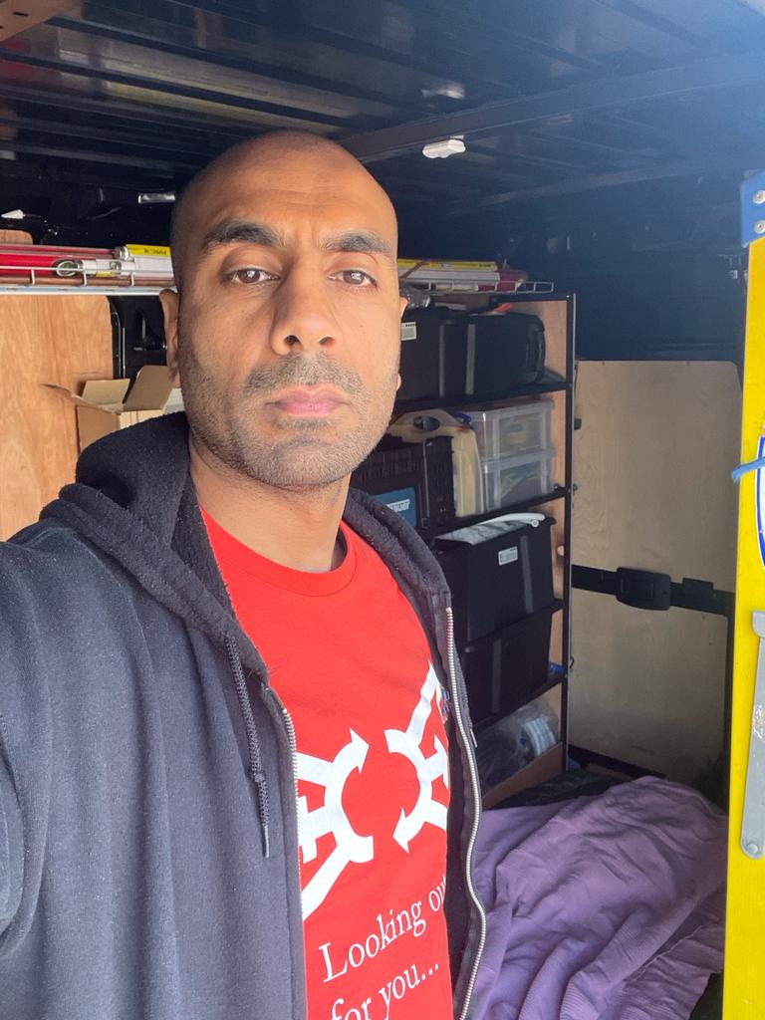
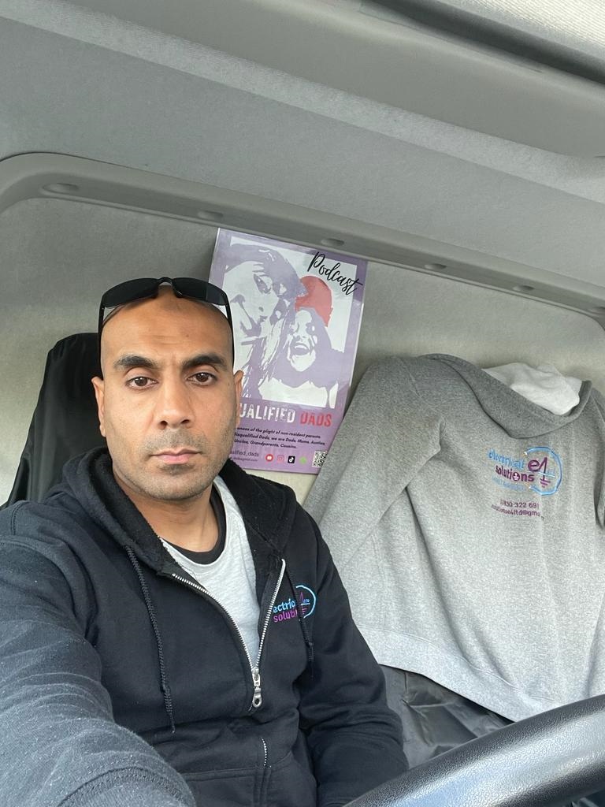
Links
Youtube channel - https://youtube.com/@disqualified_dads
Email - Disqualified.dads@gmail.com
Instagram - https://instagram.com/disqualified_dads?igshid=OGQ5ZDc2ODk2ZA==

Arpu Kumar – International Human Rights Lawyer
As a powerful, international human rights lawyer with a background in family court law Arpu Kumar has a background in family law, has studied the influence that UN conventions, SDG policies and is currently studying a doctorate in Swansea University.
Working with Split the Difference for over 2 years she has become a passionate advocate for children and fair parenting, believes that each person within a family unit has a right to be connected and to be involved, to thrive.
Arpu says: ”There are great people who have worked all their lives to support others with their right to live, love and thrive, Desmond Tutu said ‘it means a great deal to those who are oppressed to know that they are not alone’. “Some of us have the ability to step up and say we have to do this better.”
Arpu has a goal to extend her work and encourage international voices to join together and support a less top heavy approach and enable the voices of children, parents to be given a fair platform with equally positioned policies, equitable services moving forward to protect the benefits of healthy family relationships.
Split the difference defines this by promoting;
“Human rights are a constant precondition in leading a dignified human existence, serving as a guide and touchstone for legislation”
“The whole essence of Equality is that everyone deserves to have an equal voice and equal choice.“
Links - https://www.split-the-difference.com/legal-voice

Charlotte Wood, Second family volunteer
Charlotte is a volunteer that is working to promote and connect families to tell their stories. Second families are hidden victims of the child maintenance service. While the CMS is demanding paying parents pay 40% plus to first family children it does not consider the needs of the second family needs.
The effects of this denial of need pushes second family children into poverty, forcing people out of employment to cope or forcing second family mums to work more than one job in order for the CMS to be served.
Charlotte says: ”The reasons why I am part of the campaign to raise awareness with Split the Difference and attending the event in London is due to the fact that our voices aren’t heard.
“We are being punished by a draconian system that not only fails parents but all the children involved! “I am not only fighting for my stepdaughters and their rights to be part of their fathers life, but also for my son and all children and parents affected by this purely evil system! “No parent or government should be allowed to profit from human misery.”
Charlotte is very passionate about the right of children and fathers, her drive is to connect people, to support second family mums and dads.
Charlotte says: “We all have a responsibility to support better futures, I have words that encapsulates that motivation, ‘Heal the World, Make it a better place, for you and for me and the entire human race!’ (Michael Jackson).”
Contact – You can connect with Charlotte wood through Company Director Sally-Anne Burris Email - sally.burris@split-the-difference.com
Mob – 07724587078
Mr Vinnie Herts
Vinnie is a volunteer member a father who wants to be present in his children’s lives, to support and nurture their development but is battling systems that are disabling that.
Vinnie says: ”I am attending the walk of truth on the 5th July understanding what it feels like to be a victim of unfair treatment by the child maintenance service. “Their failure to follow up on conversations and forms, as well as their disrespectful treatment towards me, is discriminatory and has caused incredible financial hardship.
”I am being consistently manipulated and pushed to the point where I can't afford basic necessities. “I fear that if this continues, it will not only impact me and my child but also many others who are suffering and, tragically, some have even taken their own lives due to feeling trapped. “This situation is spiralling out of control, and it is the government's responsibility to protect us from this unfair discrimination.”
Vinnie is a committed father, is struggling with not being allowed to support and love his child in the way he feels is their right. Vinnie says: “There is a lack of transparency, a lack of accountability and a complete disregard to the external auditing processes within the CMS and DWP. “They are typically marking their own exam papers, layered with policies and procedures that are not acceptable in any other legislation, guidance or policy.”
Contact – You can connect with Vinnie through Company Director Sally-Anne Burris Email - sally.burris@split-the-difference.com
Mob – 07724587078
Samson Owen
Sam has been a volunteer with Split the Difference for over two years, he is an international volunteer bring his social media education and support to assist split in telling stories and raising awareness.
Sam says:” The experiences of fathers and second families in child maintenance services is the same in many countries, America, India, Austalia, Italy, Germany and more. It is not hard to see the destruction gender bias policies are having on children and parents who want to support them. “Togetherness is the only way to be heard, we have come together to speak for those with no voice.”
Contact – You can connect with Charlotte wood through Company Director Sally-Anne Burris Email - sally.burris@split-the-difference.com
Mob – 07724587078

Photo of Sam Owen
John Hammond
John Hammond is a paying parent that has experienced a brutal bombardment of harassment and bullying from the CMS which is documented and has lasted for over a decade. He is one of many cases attached to Split the Difference and like all the parents we have spoken too, has lived in fear of speaking out for reprisals, for example unsolicited legal action.
John says: “I will no longer be silent and suffer what the CMS has inflicted upon me and my family. I was happy to pay for my children's maintenance, but that ended ten years ago. “The CMS then found me guilty and added a fictitious arrears which crippled me without accepting my evidence or allowing me to contribute that through a fair trial.
“My namesake from the bible sums up my experience. “John 8:45 - Yet because I tell the truth, you do not believe me.”
Steve Tierney
Steve Tierney is a volunteer who is currently in university completing a psychology masters degree. Steve has been an active supportive of fathers and their families for a number of years and is respected by his professional peers.
Steve says: “I have observed that the CMS systems can disproportionately impact fathers financially. “It is clear the current legislation inadvertently promotes parental alienation, fosters a sense of entitlement, and cases show they contribute to serious societal issues such as male suicide and homelessness. “This is an area that urgently requires reform and balanced consideration. “In my own experience, alienation and abused by the CMS and their terrible corporate practises which can only be described as harassment, fits the behaviour of financial abuse but is actually worse because its unavoidable, truth and evidence is not accepted.”
Other volunteers working with Split the Difference
Eugene Tracey
Gavin Candland
Patron
Ann Widdecomb
Split the Difference is very fortunate to have supporters like our patron Ann Widdecombe an incredible woman who believes the work we do has the best interests of children, fathers and mothers. Ann has been known to say that government systems do not provide equal support and opportunities to fathers.
Link to Ann’s interviews in relation to the CMS - https://youtu.be/D8noVIvtwrE
Other public figure supporters
Split the Difference has grown over the last 4 years, we have been very fortunate to connect with some incredible human beings. Alex Reed, former MMA competitor, actor an presenter has been an incredible support of the work we do for children and their fathers and has contributed by being a guest presenter with some of our media. Alex has proven himself to be a very humanistic, real, community man, with some great skills in helping others to talk about very difficult subjects.
Link to Alex’s interviews - https://youtu.be/D8noVIvtwrE
if you are interested in parents who are experiencing the failings identified within the consultation, please contact Sally-Anne Burris, we are connected to thousands of parents and their families experiencing the illegal management of the child maintenance service. We are happy to assist in any possible to raise awareness.

